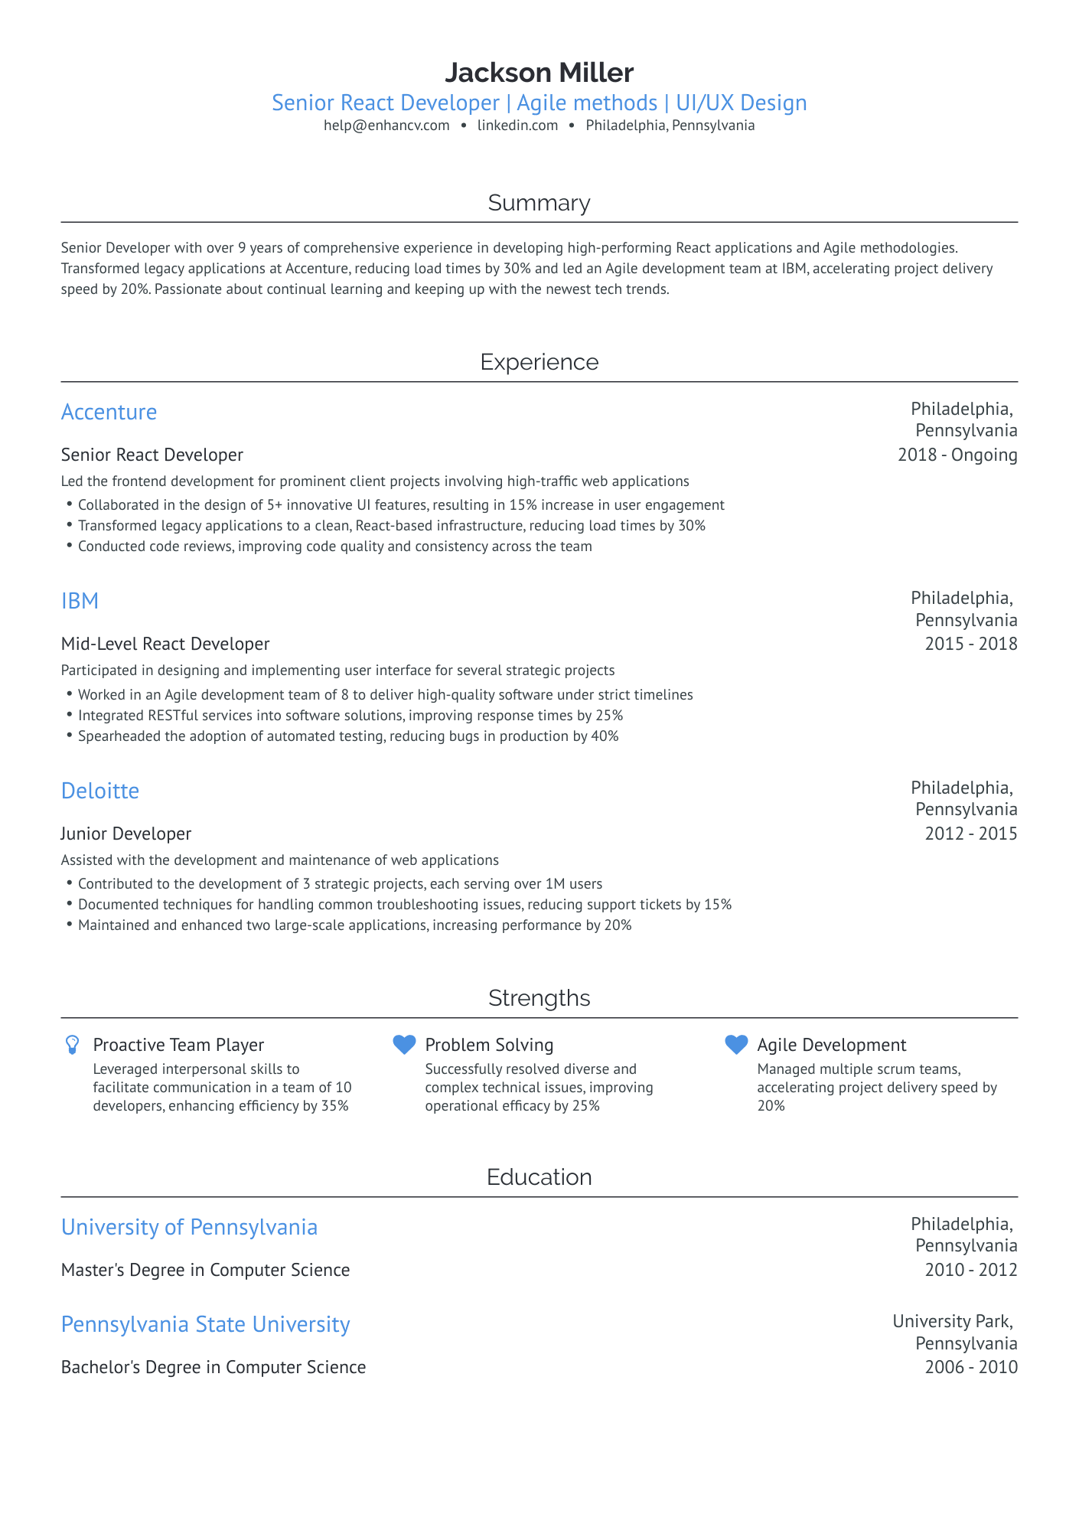
Jackson Miller
Senior React Developer | Agile methods | UI/UX Design
help@enhancv.com
linkedin.com
Philadelphia, Pennsylvania
Summary
Senior Developer with over 9 years of comprehensive experience in developing high-performing React applications and Agile methodologies. Transformed legacy applications at Accenture, reducing load times by 30% and led an Agile development team at IBM, accelerating project delivery speed by 20%. Passionate about continual learning and keeping up with the newest tech trends.
Experience
Accenture
Senior React Developer
Led the frontend development for prominent client projects involving high-traffic web applications • Collaborated in the design of 5+ innovative UI features, resulting in 15% increase in user engagement
• Transformed legacy applications to a clean, React-based infrastructure, reducing load times by 30% • Conducted code reviews, improving code quality and consistency across the team
IBM
Mid-Level React Developer
Philadelphia,
Pennsylvania 2018- Ongoing
Philadelphia, Pennsylvania 2015-2018
Participated in designing and implementing user interface for several strategic projects
• Worked in an Agile development team of 8 to deliver high-quality software under strict timelines
• Integrated RESTful services into software solutions, improving response times by 25%
• Spearheaded the adoption of automated testing, reducing bugs in production by 40%
Deloitte
Junior Developer
Assisted with the development and maintenance of web applications
• Contributed to the development of 3 strategic projects, each serving over 1M users
• Documented techniques for handling common troubleshooting issues, reducing support tickets by 15%
• Maintained and enhanced two large-scale applications, increasing performance by 20%
Philadelphia, Pennsylvania 2012-2015
Proactive Team Player
Leveraged interpersonal skills to
facilitate communication in a team of 10 developers, enhancing efficiency by 35%
Strengths Problem Solving
Successfully resolved diverse and complex technical issues, improving operational efficacy by 25%
Agile Development
Managed multiple scrum teams, accelerating project delivery speed by
20%
University of Pennsylvania
Master's Degree in Computer Science
Pennsylvania State University
Bachelor's Degree in Computer Science
Education
Philadelphia, Pennsylvania
2010-2012
University Park,
Pennsylvania
2006-2010

